

Lab Journal: 05
Date: 10/07/2025

Student : Lotfullah Muslimwal
Enrollment : 01-131232-039

Department of Software Engineering

Bahria University, Islamabad

Software Construction-Lab (Fall-2025)
Teacher: ENGR. SAAD MAZHAR

Task No: | Task Wise Marks |  | Documentation Marks |  | Total Marks  (20)
Task No: | Assigned | Obtained | Assigned | Obtained | Total Marks  (20)
1 | 3 |  | 5
2 | 3 |  | 5
3 | 3 |  | 5
4 | 3 |  | 5
5 | 3 |  | 5

Comments:

Signature

Lab 05 – Object Interaction II: Task File

GitHub Repo: Lab 5 Code

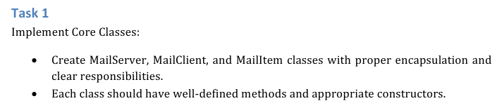

Code for Task 1
import java.util.ArrayList;
import java.util.HashMap;
import java.util.List;
import java.util.Map;
import java.util.Scanner;
class MailItem {
private final String from;
private final String to;
private final String message;
public MailItem(String from, String to, String message) {
this.from = from;
this.to = to;
this.message = message;
}
public String getFrom() {
return from;
}
public String getTo() {
return to;
}
public String getMessage() {
return message;
}
public void displayMail() {
System.out.println("From: " + from);
System.out.println("To: " + to);
System.out.println("Message: " + message);
System.out.println("----------------------------");
}
@Override
public String toString() {
return "From: " + from + "\nTo: " + to + "\nMessage: " + message;
}
}
class MailServer {
private static MailServer instance;
private Map<String, MailClient> clients;
private MailServer() {
clients = new HashMap<>();
}
public static MailServer getInstance() {
if (instance == null) {
instance = new MailServer();
}
return instance;
}
public void registerClient(MailClient client) {
if (!clients.containsKey(client.getUsername())) {
clients.put(client.getUsername(), client);
} else {
System.out.println("Username '" + client.getUsername() + "' is already registered.");
}
}
public boolean userExists(String username) {
return clients.containsKey(username);
}
public void sendMail(MailItem mail) {
String recipient = mail.getTo();
if (clients.containsKey(recipient)) {
clients.get(recipient).receiveMail(mail);
System.out.println("Mail sent successfully to " + recipient + "!");
} else {
System.out.println("Error: Recipient '" + recipient + "' does not exist!");
}
}
public MailClient getClient(String username) {
return clients.get(username);
}
// Optional reset for testing/debugging
public void resetServer() {
clients.clear();
System.out.println("MailServer reset completed.");
}
}
class MailClient {
private String username;
private List<MailItem> inbox;
private MailServer server;
public MailClient(String username, MailServer server) {
this.username = username;
this.server = server;
inbox = new ArrayList<>();
this.server.registerClient(this);
}
public String getUsername() {
return username;
}
public void sendMail(String to, String message) {
if (message == null || message.trim().isEmpty()) {
System.out.println("Error: Message cannot be empty!");
return;
}
MailItem mail = new MailItem(this.username, to, message);
server.sendMail(mail);
}
public void receiveMail(MailItem mail) {
inbox.add(mail);
}
public void showInbox() {
System.out.println("\nInbox of " + username + ":");
if (inbox.isEmpty()) {
System.out.println("No messages.");
} else {
for (MailItem mail : inbox) {
mail.displayMail();
}
}
}
}
public class Task1 {
public static void main(String[] args) {
Scanner sc = new Scanner(System.in);
MailServer server = MailServer.getInstance();
System.out.println("=== Welcome to Java Mail System ===");
while (true) {
System.out.println("\n1. Register User");
System.out.println("2. Send Mail");
System.out.println("3. Check Inbox");
System.out.println("4. Exit");
System.out.print("Choose an option: ");
int choice = sc.nextInt();
sc.nextLine();
switch (choice) {
case 1:
System.out.print("Enter new username: ");
String username = sc.nextLine().trim();
if (server.userExists(username)) {
System.out.println("Username already exists!");
} else {
new MailClient(username, server);
System.out.println("User '" + username + "' registered successfully!");
}
break;
case 2:
System.out.print("Enter your username: ");
String sender = sc.nextLine().trim();
if (!server.userExists(sender)) {
System.out.println("You need to register first!");
break;
}
System.out.print("Enter recipient username: ");
String recipient = sc.nextLine().trim();
System.out.print("Enter your message: ");
String message = sc.nextLine();
server.getClient(sender).sendMail(recipient, message);
break;
case 3:
System.out.print("Enter your username: ");
String user = sc.nextLine().trim();
if (!server.userExists(user)) {
System.out.println("User does not exist!");
break;
}
server.getClient(user).showInbox();
break;
case 4:
System.out.println("Exiting Java Mail System. Goodbye!");
sc.close();
System.exit(0);
default:
System.out.println("Invalid option! Try again.");
}
}
}
}

Screenshot
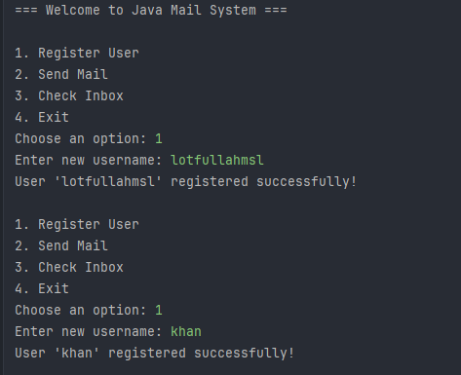
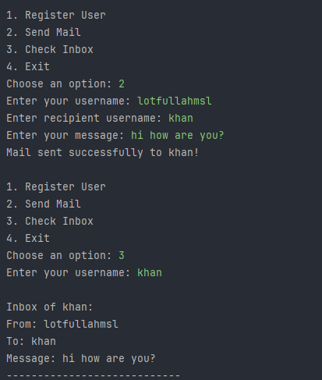
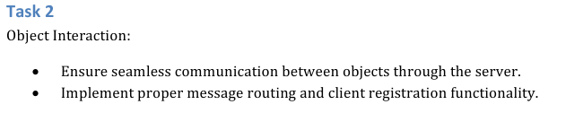

Task 2 – Object Interaction
In this task, I worked on making sure all the classes — MailServer, MailClient, and MailItem — could properly communicate with each other.
When a new user (MailClient) is created, it automatically registers itself with the server. After that, any message sent by one user goes through the MailServer, which delivers it to the correct recipient’s inbox.
I tested this by creating multiple users and sending messages between them. The messages were received successfully in the right inboxes, showing that the interaction between objects is working smoothly.
Overall, this task helped me understand how different classes connect and pass information in an object-oriented program. It also showed how the server controls communication instead of clients directly interacting with each other.

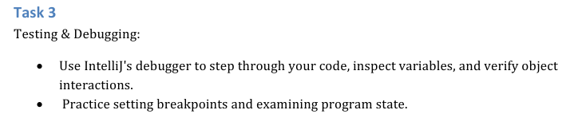
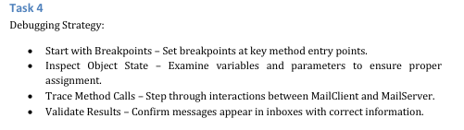
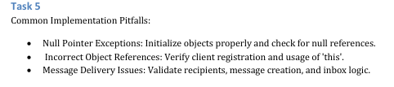

- Choose points to debug.
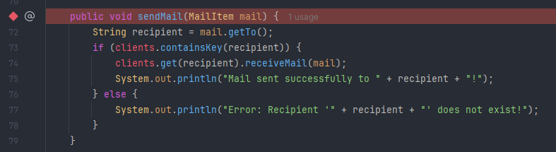
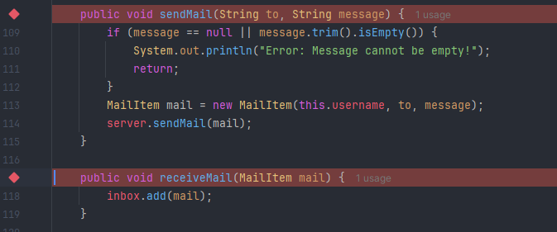
- Variable Pannel after debugging, so its mean the message is sended successfully
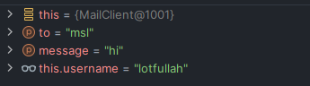
- Went inside the method using the F7 Button
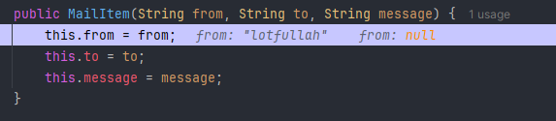

- Move to the next line in the same method F8 Button.
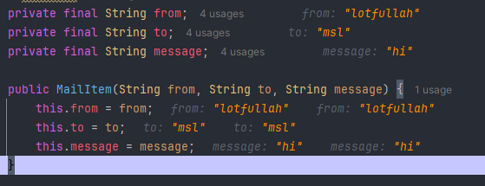
- Going through the next method using F9

Task 3, 4, 5: all are including in the above screenshots it including the checkpoints and using debugging and deferent parts of it .

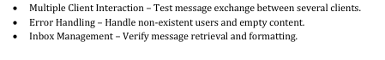
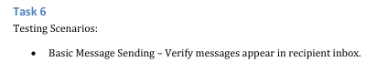

Checking the code with the Different invalid inputs
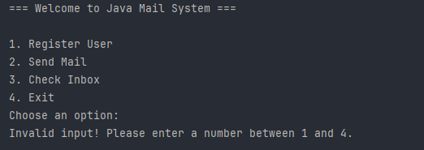
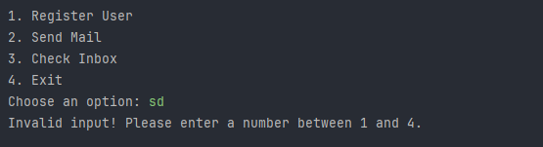
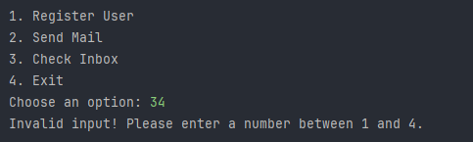

Conclusion
In this lab, we successfully built a simple Java Mail System to understand how objects interact in an object-oriented program. We implemented three core classes: MailItem, MailClient, and MailServer, each with clear responsibilities. The MailClient can send and receive messages, while the MailServer manages users and ensures messages are delivered correctly.
We learned how objects communicate with each other through proper method calls and registration, ensuring that messages are routed to the right recipients. During the lab, we also practiced debugging strategies, using breakpoints and inspecting object states to trace how data flows between objects.
The lab emphasized the importance of handling common programming issues such as null references, incorrect object usage, and message delivery errors. We also implemented input validations to prevent invalid usernames, empty messages, and other errors.
Finally, through testing scenarios, we verified that:
- Messages are correctly sent and received,
- Multiple clients can interact simultaneously,
- Error handling works for invalid users or empty content,
- Inboxes display messages properly and in a readable format.
Overall, this lab helped us understand object interaction, message routing, debugging, and error handling in Java, giving a clear idea of how multiple objects can work together in a real-world system.

